Module E—Interactive

Web Technologies

Submitted by:

Thomas Mak

# Contents

1. Contents 2
2. Introduction 3
3. Description of project and tasks 3
   1. Scene construction 3
      1. Special Game Objects in the scene 4
      2. Parallax game objects 4
      3. Interactivity: Sound 4
   2. Avatar movement 4
   3. Scene switching 5
   4. Learning Activity: Quiz 5
   5. Use of API 5
4. Instructions to the Competitor 5
5. Equipment, machinery, installations, and materials required 6
6. Marking Scheme 6

# Introduction

In this project, we would like to create a game for kids learning.

It is a simple virtual world. Player can control the avatar to move left and right. And progress to different scenes while moving to the left edge or right edge of the game screen.

The game can be toggled into full-screen, without seeing the task bar and browser UI.

# Description of project and tasks

Please find the details below.

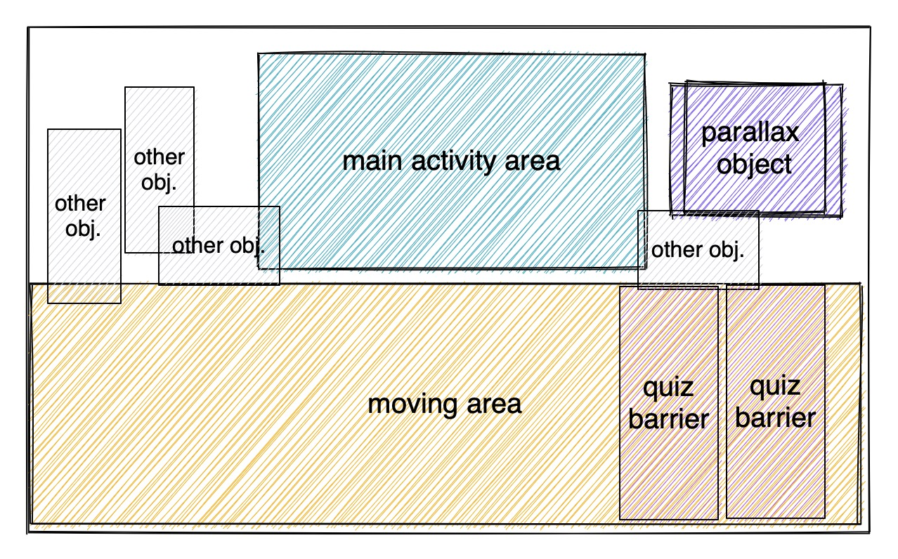

## Scene construction

For each scene, the bottom part is area where avatar may move. The upper part of the scene is constructed by different scene objects.

There are seneral object types per scene, they are:

* main activity area
* right game objects, with slightly parallax effect.
* other game objects.
* quiz barriers on the avatar-moving area on right edge of the screen.

When avatar moves to the right edge, and touch or near to the quiz barrier, the corresponding quiz shows.

During the video playback, the the video should play inline while in PC.

Scene creation has animation to present the scene objects one by one. Please don’t make the animation too slow that cannot be assessed.

### Special Game Objects in the scene

There are different game objects designed for the scene. They are prepared when in the media files, grouped by folder named for each scene.

You can refer to the media files on the placements of the game objects for each scene.

The scene document in media files also describes the z-index for each game objects provided. Please follow it when constructing the scene.

Here are some special game objects that provide interactivity:

* Learning activities barriers
  + There are learning activity barriers on the road, blocking the road.
  + Avatar cannot go through these barriers. The avatar need to clear the barriers on the roads before they can move to the next scene by reaching the right edge of the screen.
  + The learning activity dialog shows when either the following happens:
    - When the avatar moves and hits the barrier.
    - or When the player directly click or tap on the barrier, regardless of the avatar’s current position.
  + When hitting the activity barriers by the avatar, the activity show in a dialog.
  + (Hitting means the avatar is very close to the barrier visually)
  + Please refer to the learning activities details description in this document for details on what’s showing up.
  + When the learning activities shows, the “learning-activity” sound effect is played.
* Main activity object, either a video or an image
  + When user click or tap on the videos, the video plays, inline in the embed player
  + When scene contains no video, there is an image in the middle area of scene.
* Parallax rotation on the object at right-hand side of the scene
  + When the mouse over on this object, there is parallax effect. See details below.
* Other game objects
  + When clicking or tapping on other game objects, the “object-sound” sound effect is played.
  + Clicking on the scene objects on screen will animate the object a little bit, in any forms.

### Parallax game objects

In the scene, there may be at most one object that has subtle parallax rotation effect.

The objects with parallax effect should have good feeling of parallax.

Giving the parallax effect may be fine tuned by the animation experts, the amount of parallax feeling should be easily configured in code for non-prorgrammers to adjust.

One example of the parallax game effect is recorded in the media file.

### Interactivity: Sound

Clicking on the designed objects produces specific sound. Sound files can be found in media files.

Clicking on the scene objects on screen will animate the object a little bit, in any forms.

## Avatar movement

Player can control and the avatar by keyboard and directly clicking/tapping on the game screen.

When using keyboard, player can press the arrow keys to move the avatar. When using touch screen, player can tap the screen to move the avatar directly to that position, unless the tapped area is not able to walk on.

When using mouse, player can click on the area and the behavior is similar to the tapping of the screen.

When tapping or clicking on the screen, an animation should show the clicked/tapped point to showcase the point where the avatar is heading to.

The avatar position is saved via LocalStorage. And the avatar position can be resumed when web page loads or refresh.

## Scene switching

When the avatar moves to the left/right of the screen, the scene changes to the next/previous scene. If there is unfinished quiz barrier, the avatar can’t move to the right edge of the scene. Thus player cannot change scene until finishing all quiz barriers.

During the scene switching, the scene objects in current scenes goes out with transition and the new scene comes out with transition too.

## Learning Activity: Quiz

Quiz learning activity happens when the avatar hits the quiz barrier. The quiz shows a text-only multiple choice, four-choose-one.

The quiz showing should be animated with energtic feeling to provide not boring experience to the yound readers that is learning. Seleting any choices should also give an energetic feeling of animation.

The quiz stays when the selection is incorrect. The quiz goes away and the quiz barrier is removed after choosing correct answer.

## Use of API

This game will be uploaded to the game platform. So it uses the API provided by the game platform. After the game ends while player finishing all quizzes, the count of total correct quizzes (equal to the amount of quizzes) is post to the game platform via the score saving API. Please show an error if the score saving fails.

API reference:

The message the game has to send to the parent via `window.parent.postMessage(...)` looks like this:

{

"event_type": "game_run_end",

"score": 100

}

# Instructions to the Competitor

* Project should be accessible via /XX_module_e/ where XX is the workstation number.
* All assessment is done on server. No assessment process in workstation.
* You should consider the quality of code.

# Equipment, machinery, installations, and materials required

|  |  |  |  |  |
| --- | --- | --- | --- | --- |
| ITEM | quantity | material | description | notes |
| - | - | - | - | - |

# Marking Scheme

|  |  |  |  |  |  |  |
| --- | --- | --- | --- | --- | --- | --- |
|  |  | Communication and Presentation | Design | Layout | Front-end | Total |
| E1 | Avatar movement | 0.5 | 0.5 | - | 3.5 | 4.5 |
| E2 | Scene construction and switching | - | 1.75 | 1.25 | 2 | 5 |
| E3 | Learning Activities | - | 2 | 2.5 | 2 | 6.5 |
|  | Total |  |  |  |  | 16 |